Laptop Request Catalog Item

**Team ID: NM2025TMID15692**

**Team Size: 4**

**Team Leader: Dhanalakshmi .R**

**Team member: Deepika .B**

**Team member: Ramani .K**

**Team member: Yuvasri .S**

**Project Overview:**

This project, Laptop Request Catalog Item, is implemented using the Service Now platform. The objective is to provide employees a simple and efficient way to request laptops through a digital service catalog. The system automates form filling, approvals, and request tracking. It ensures accuracy in data collection, provides dynamic form behavior with UI Policies, supports UI Actions like reset/submit, and allows administrators to manage changes using update sets. This improves efficiency, reduces manual delays, and enhances IT service management in organizations.

**Objectives:**

1. To create a Laptop Request Catalog Item in Service Now.
2. To use UI Policies for dynamic form behavior (show/hide fields, mandatory rules).
3. To use UI Actions for additional functionalities (reset, submit).
4. To manage configuration through Update Sets for easy migration.
5. To ensure request tracking, testing, and deployment in another instance.

**Tools and Technologies:**

* Platform: Service Now (Developer Instance)
* Modules Used: Catalog items, update sets, UI Policy, UI Action, Work flow , Testing Module
* Languages: JavaScript (for client scripts)

**Skills Used:**

* Service Now Administration
* Form Design & customization
* Configuration Management
* Problem-Solving & Logical Thinking
* Testing & Deb

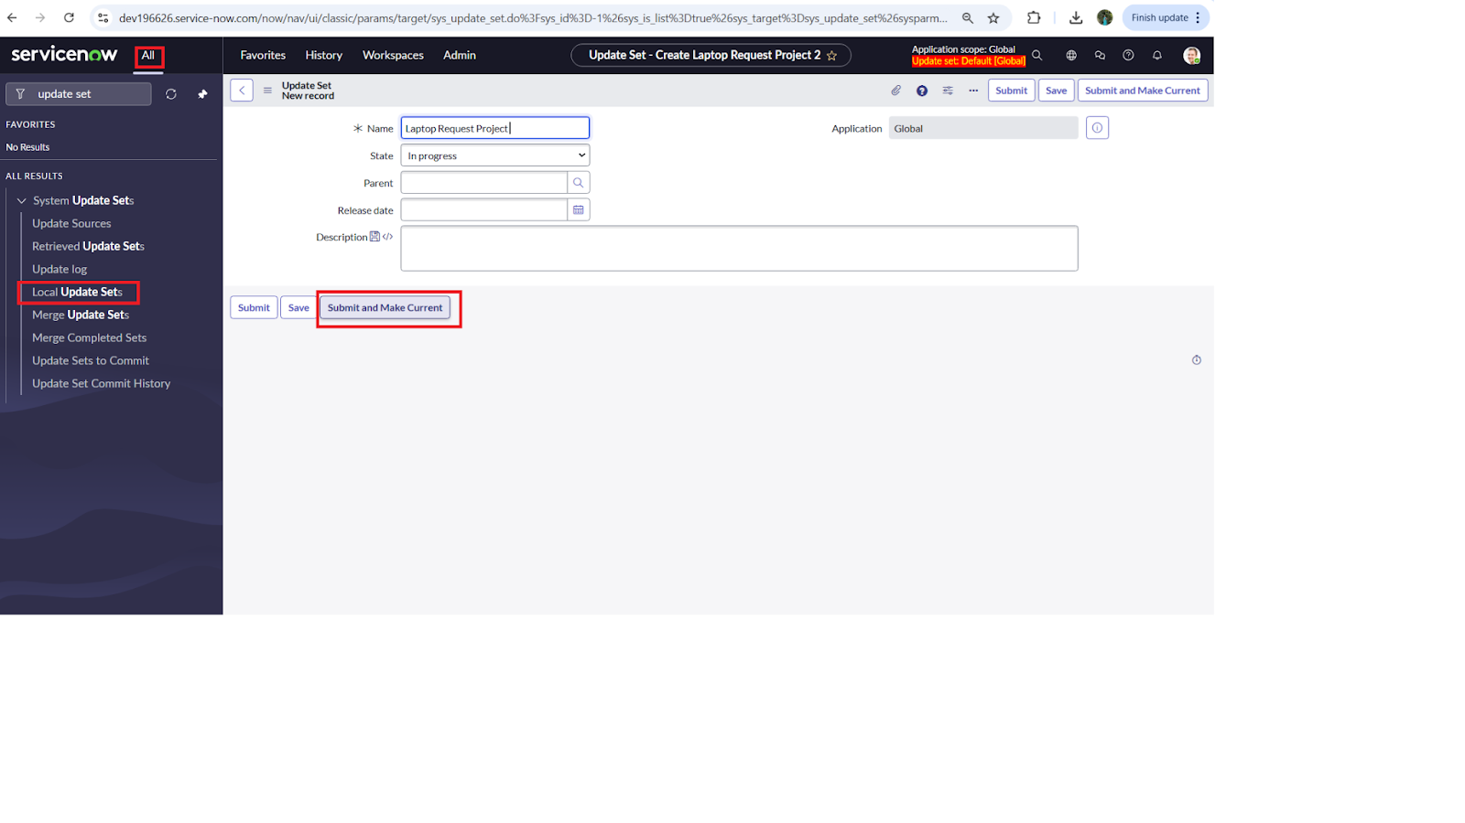

**TASK INITIATION:**

**Milestone 1 : Creating a Update Set.**

* Navigated to All → Local Update Sets
* Created a update set as laptop Request
* Update set activated

**Milestone 2 : Service Catalog Item**

**Activity 1: Create Service Catalog Item**

* Open Service Now and login as System Administrator.
* In the left navigation menu, click on All → Service Catalog.
* Under Catalog Definitions, select Maintain Items.
* Click on New to create a new catalog item.
* Fill in the following details:
* Name: Laptop Request
* Catalog: Service Catalog
* Category: Hardware
* Short Description: Use this item to request a new laptop
* Click on Save to create the catalog item.

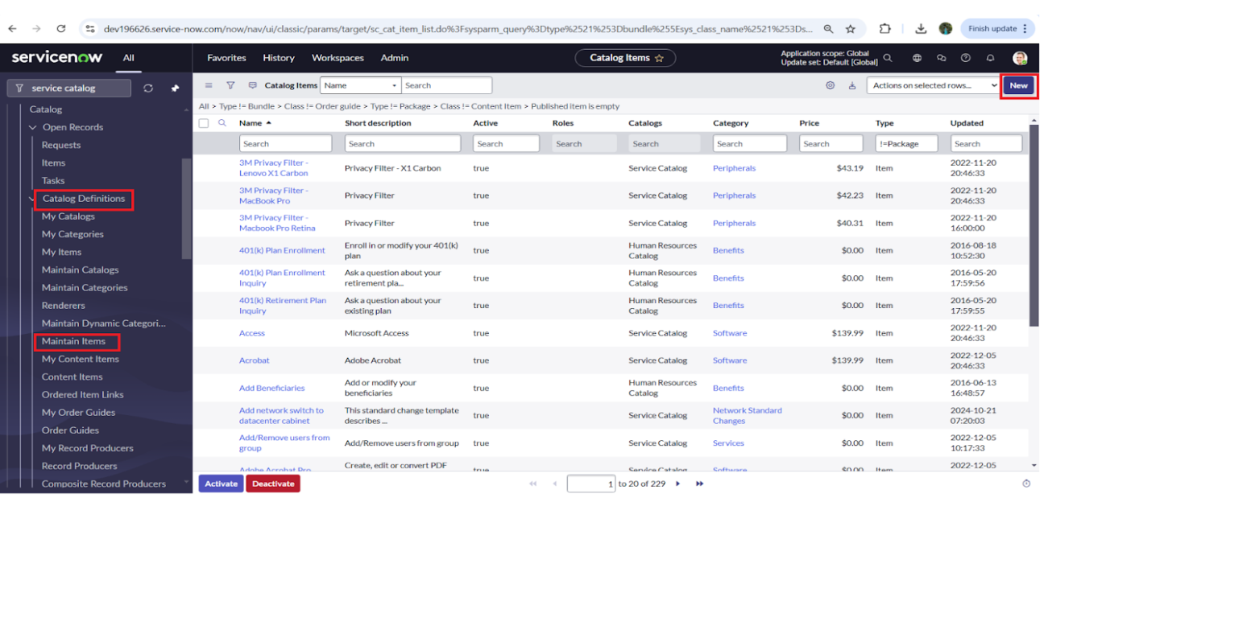

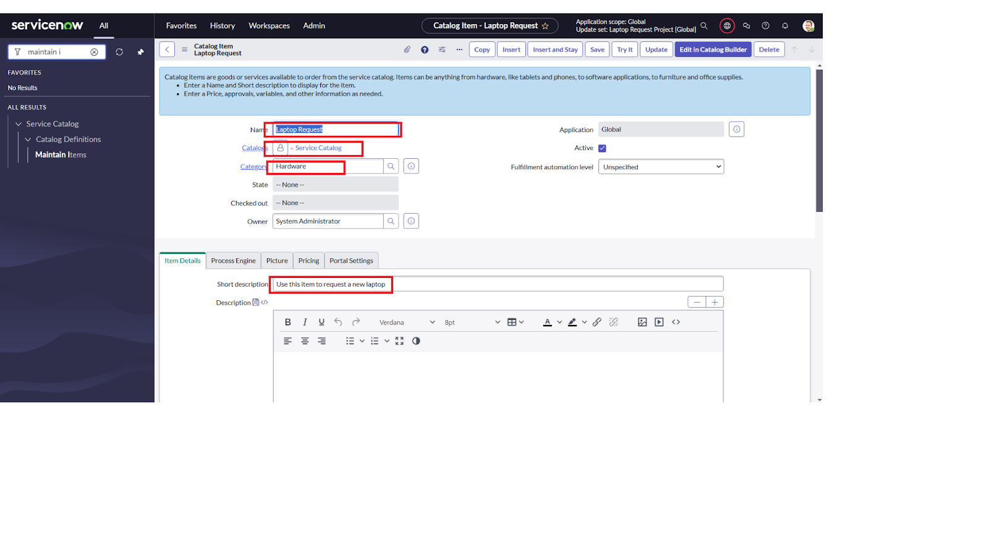

**Activity 2: Add Variable**

**Step 1:** After saving the Catalog Item form, scroll down and click on Variables (Related List).

**Step 2:** Click new and enter the details as below:

1. Variable 1: Laptop Model

Type: Single Line Text

Name: laptop_model

Order: 10

Click Submit

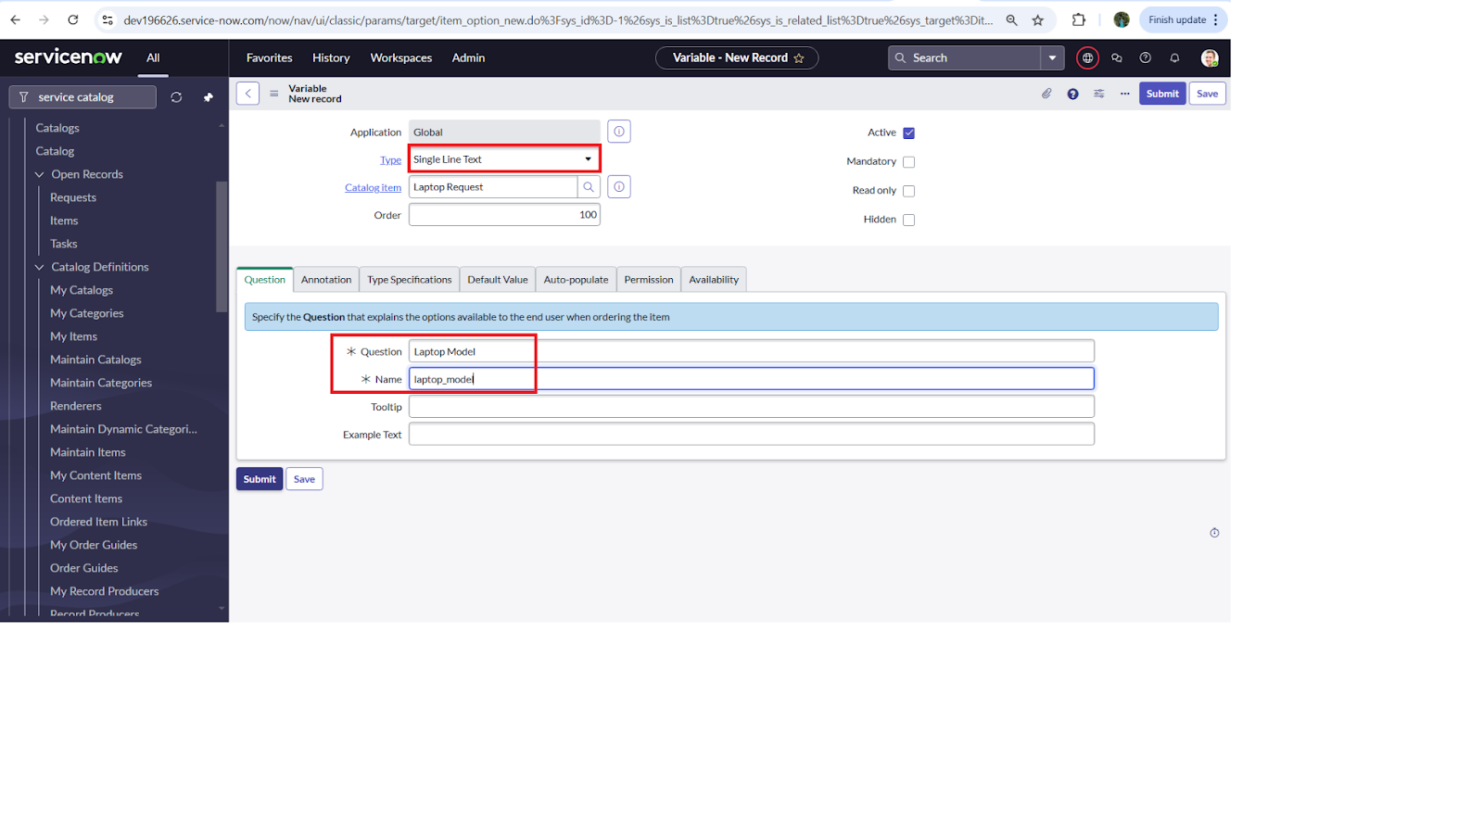

**Step 3:** Repeat the same process to add the remaining variables:

2. Variable 2: Justification

Type: Multi Line Text

Name: justification

Order: 200

3. Variable 3: Additional Accessories

Type: Checkbox

Name: additional_accessories

Order: 300

4. Variable 4: Accessories Details

Type: Multi Line Text

Name: accesseries_details

Order: 400

**Step 4:** After adding all the variables, save the Catalog Item form.

**Milestone 3: UI Policy**

**Activity 1: Create Catalog UI Policies**

**Step 1:** Open All → Service Catalog.

**Step 2:** Select Maintain Items under Catalog Definition.

**Step 3:** Search for Laptop Request.

**Step 4:** Open Laptop Request and scroll down. Click on Catalog UI Policies.

**Step 5:** Click New and fill in the details:

Short Description: Show Accessories Details

When to Apply Condition:

Field: additional_accessories

Operator: is

Value: true

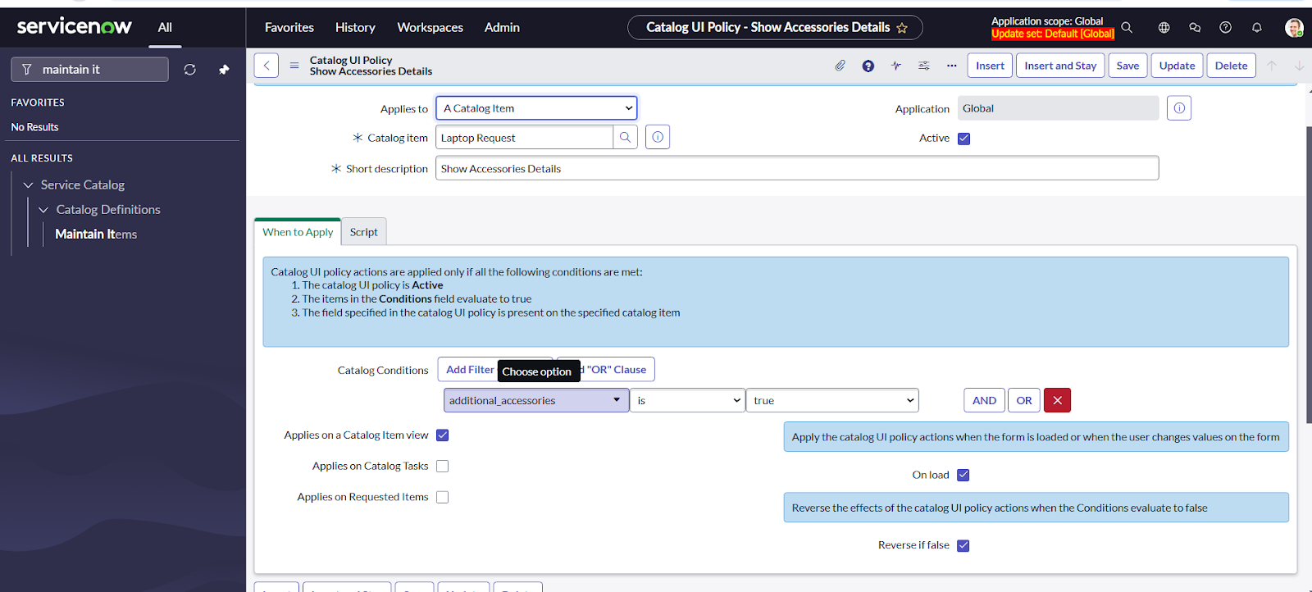

Click Save.

**Step 6:** Scroll down and go to the Catalog UI Policy Action.

**Step 7:** Click new and fill in the details:

Variable Name: accessories_details

Order: 100

Mandatory: True

Visible: True

Click Save.

**Step 8:** Finally, click Save again on the Catalog UI Policy form.

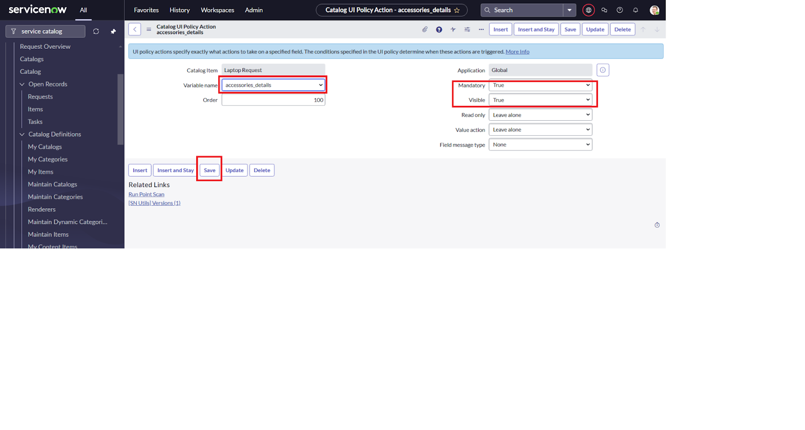

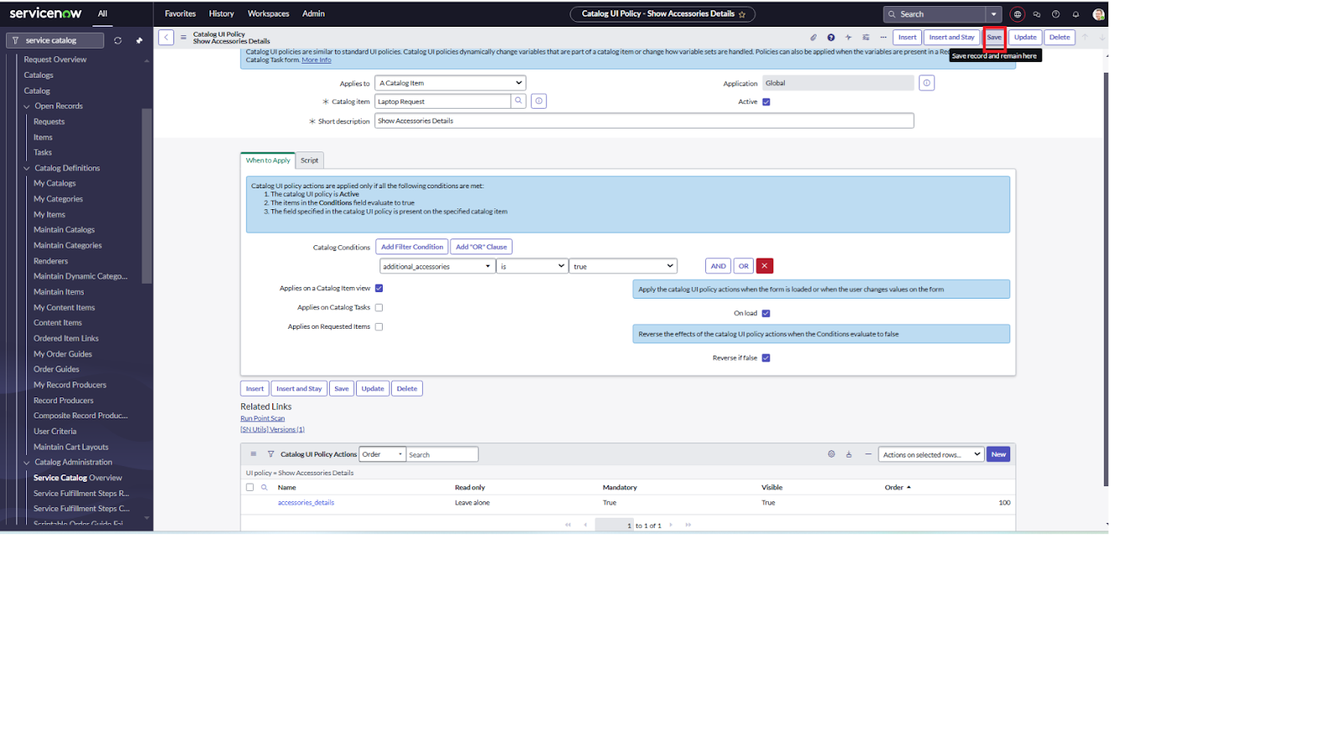

**Milestone 4 : UI Action**

**Activity 1: Create UI Action**

**Step 1:** Open Service Now.

**Step 2:** Click on All → Search for UI Actions.

**Step 3:** Select UI Actions under System Definition.

**Step 4:** Click on New.

**Step 5:** Fill in the details:

Table: Shopping Cart (sc_cart)

Order: 100

Action Name: Reset Form

Client: Checked

**Step 6:** Add the following Script:

function resetForm() {

g_form.clearForm(); // Clears all fields in the form

alert("The form has been reset.")

}

**Step 7:** Click Save.

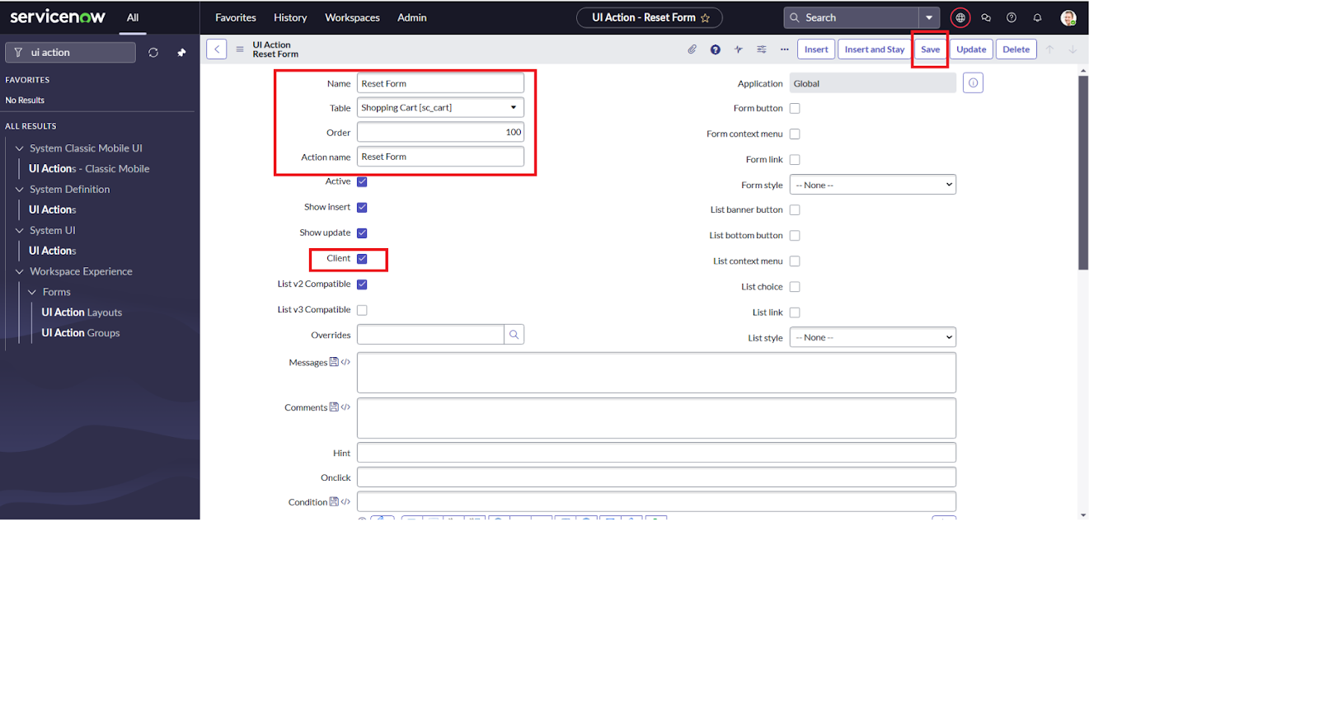

**Milestone 5 : Export Update Set**

**Activity 1: Exporting Changes to Another Set**

**Step 1:** Open All → Search for Update Sets.

**Step 2:** Select Local Update Set.

**Step 3:** Choose the created update set (e.g., Laptop Request Project).

**Step 4:** Set the State to Complete.

**Step 5:** In the Related List → Updates tab, verify that all performed updates are visible.

**Step 6:** Click on Export to XML.

This will download the update set as an XML file.

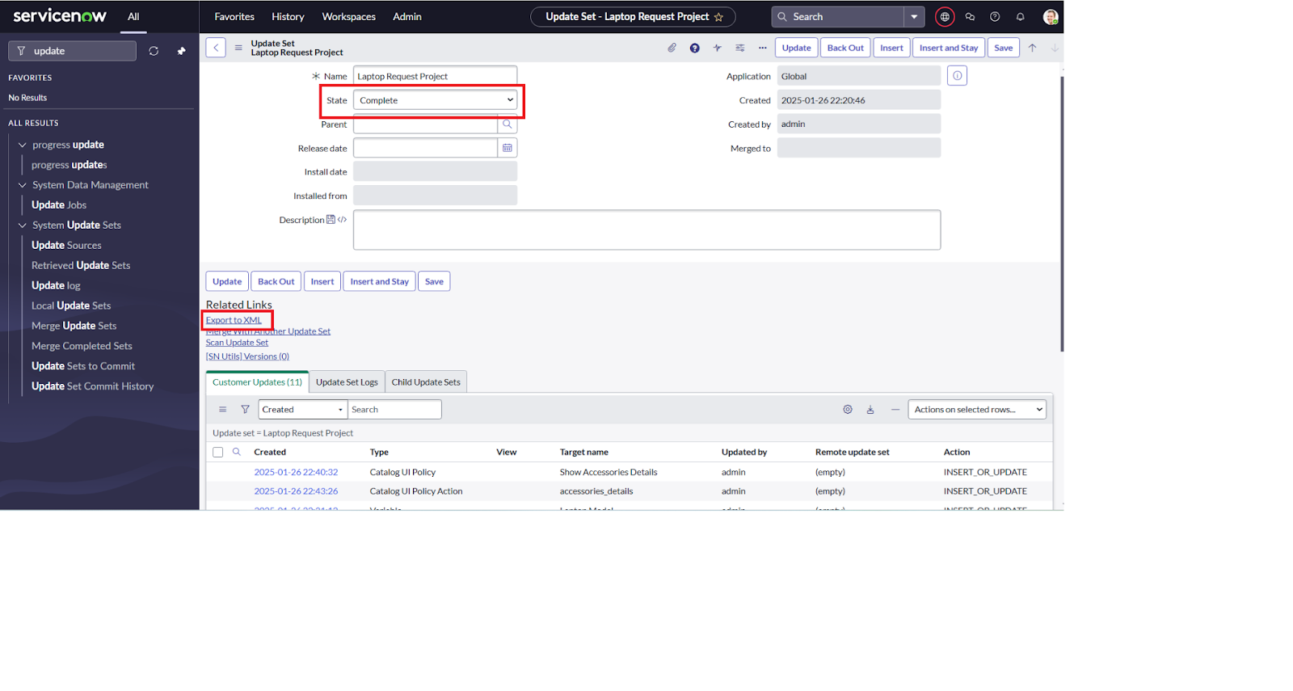

**Milestone 6: Login To Update Set**

**Activity 1: Retrieving the Update Set**

**Step 1:** Open another Service Now instance in Incognito Window.

**Step 2:** Login with valid credentials.

**Step 3:** Click on All → Search for Update Sets.

**Step 4:** Select Retrieved Update Set under System Update Sets.

**Step 5:** In the Retrieved Update Set list, scroll down and click Import Update Set from XML.

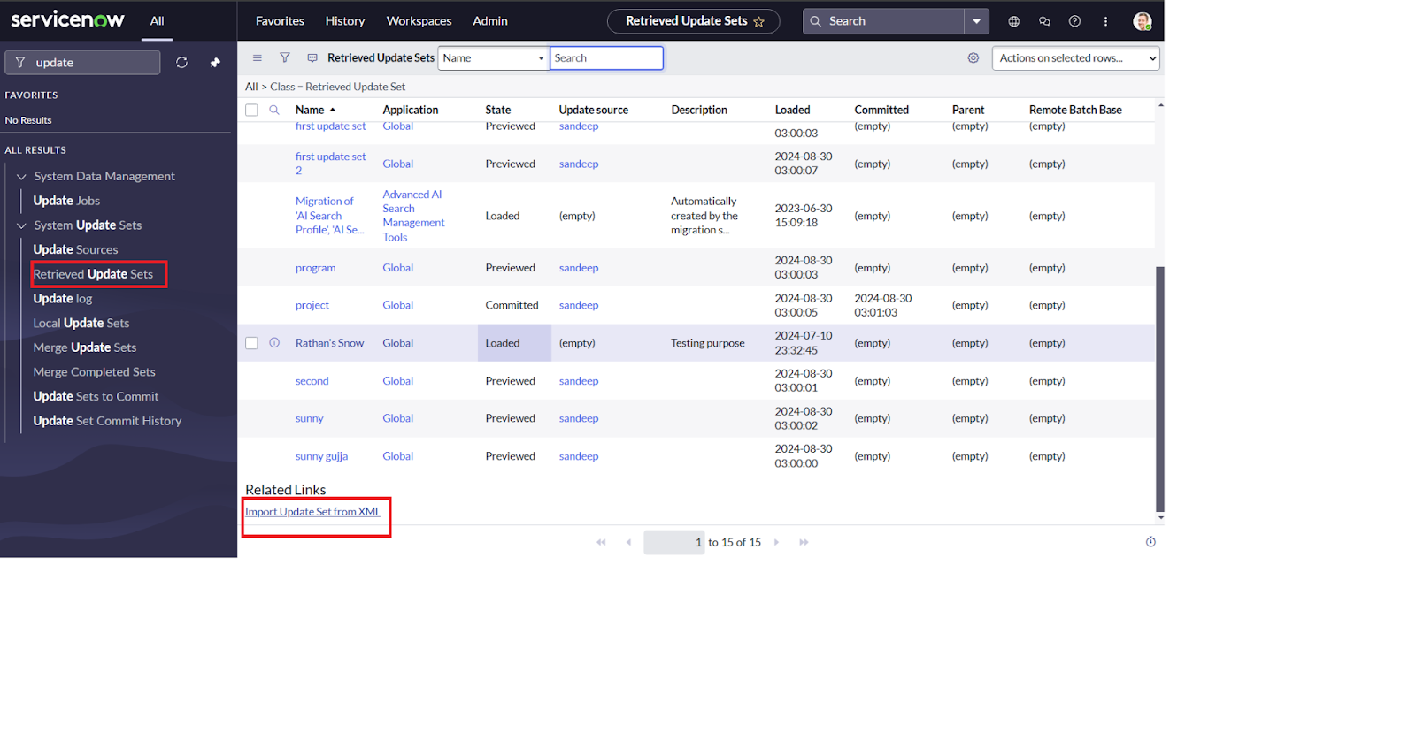

**Step 6:** Upload the previously downloaded XML file.

**Step 7:** Click on Upload → The update set will be imported

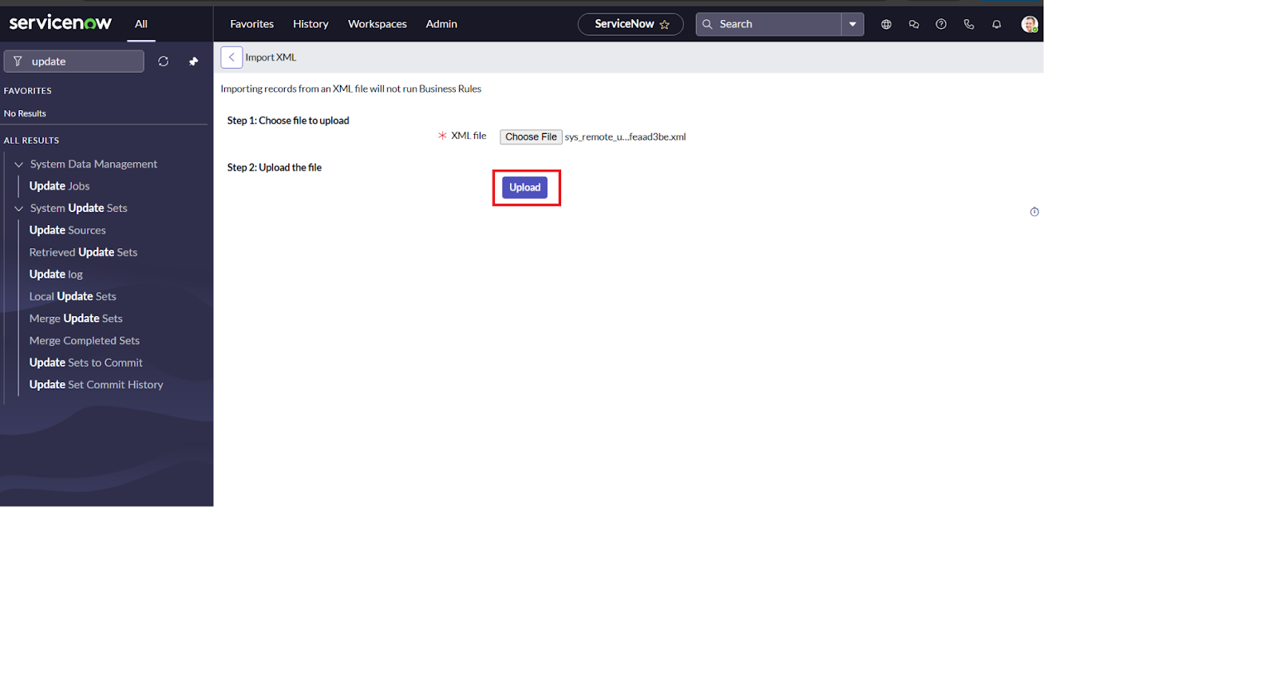

**Step 8**: Open the retrieved update set (Laptop Request Project).

**Step 9:** Click on Preview Update Set.

**Step 10:** Click on Commit Update Set.

**Step 11:** Check the Related List → Updates tab to confirm all updates are applied.

* After committing, all updates from the previous instance will be available in the new instance.

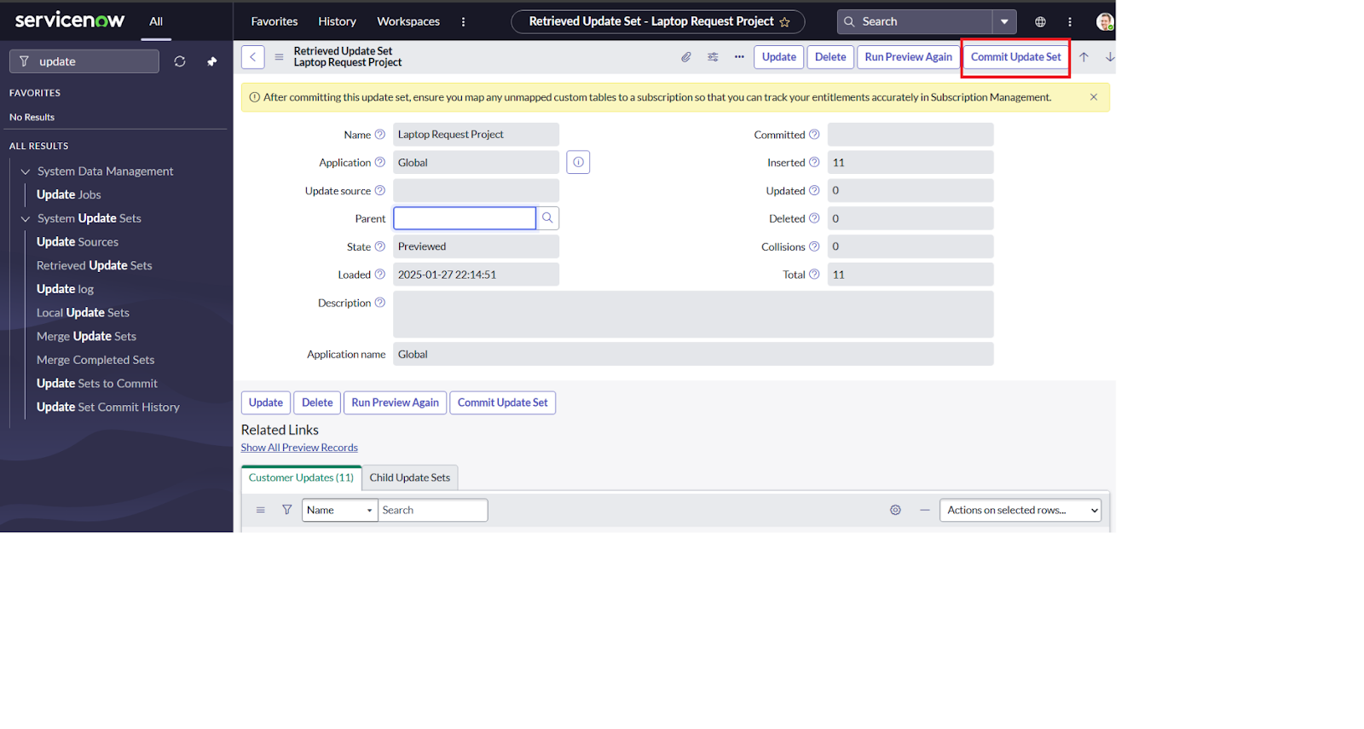

**Milestone 7: Testing**

**Activity 1: Test Catalog Item**

**Step 1:** Search for Service Catalog in the Application Navigator of the target instance.

**Step 2:** Select Catalog under Service Catalog.

**Step 3:** Choose the Hardware category and search for the item Laptop Request.

**Step 4:** Open the Laptop Request item.

**Step 5:** Verify that it shows three variables only by default.

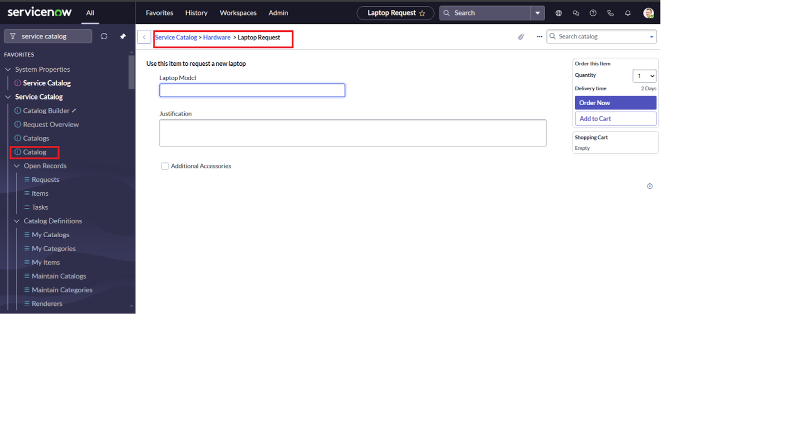

**Step 6:** Check the scenario:

When you select the Additional Accessories checkbox → The Accessories Details field becomes visible and Mandatory.

**Step 7:** Confirm that the results full fill the project requirements.

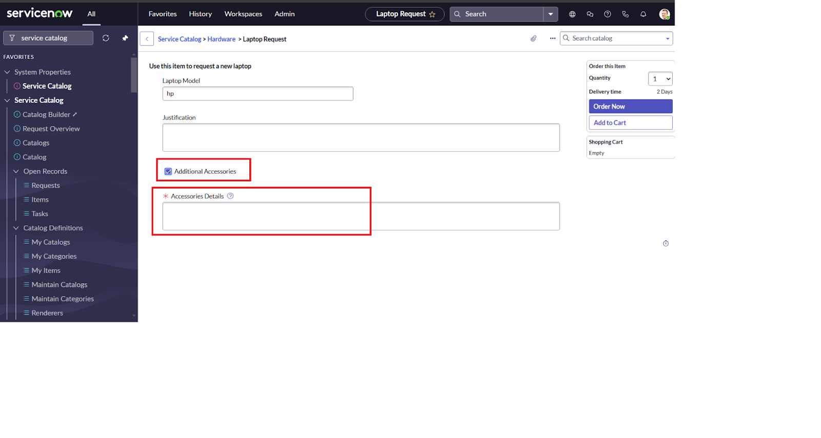

**Conclusion:**

The Laptop Request Catalog Item Project successfully streamlines the process of requesting laptops within the organization by utilizing Service Now's Service Catalog capabilities. By implementing a dynamic catalog item with variables, UI policies, and actions, the project ensures that users have an intuitive and user-friendly interface. This reduces errors, improves efficiency, and enhances the overall service delivery process.

The project clearly demonstrates how Service Now can replace manual, error-prone methods with automated, efficient, and user-centric solutions. Ultimately, it not only improves IT service management but also enhances employee satisfaction by providing a modern, reliable, and streamlined request experience.